**MARMORA HARDWARE**

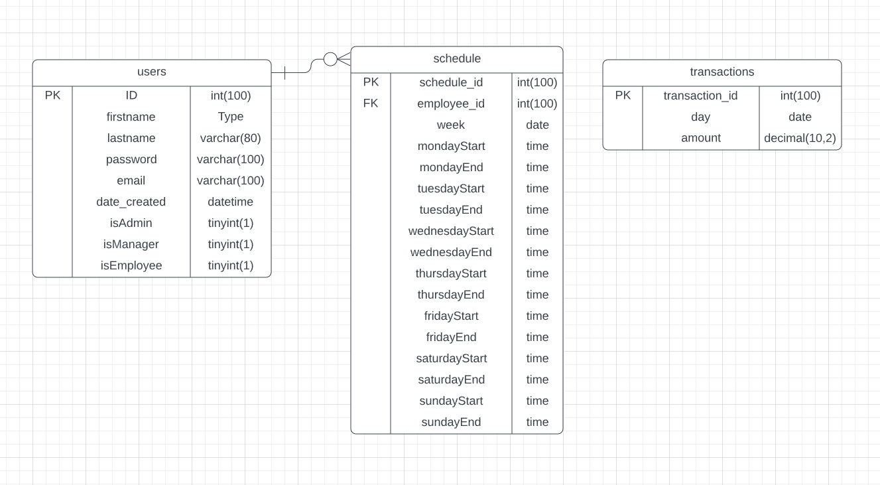

**1. TEAM MEMBERS**

Chris Ricchi

Kyle Antczak

Van Nguyen

Christopher Bakley

**2. CUSTOMER STATEMENT OF REQUIREMENTS**

**2.1. PROBLEM STATEMENT**

Marmora Hardware, a successful family-owned local hardware store, has been relying on manual systems for over 60 years to manage all aspects of their business operations. This approach has become increasingly inefficient and error-prone in the face of an ever-evolving technology-driven society. The lack of a technology-based management system has resulted in challenges with checkout systems, inventory management, staffing and scheduling, sales logs, and record-keeping. All records, logs, and data are currently maintained in hardcopy format on-site, which is labor-intensive and prone to errors.

This approach has made it difficult for the business to expand its customer base, market its products effectively, and operate efficiently to remain competitive. Therefore, there is an urgent need for a modern, technology-based solution to address these issues and allow the business to thrive and evolve.

**2.2. PROPOSED SOLUTIONS**

To address the issues faced by Marmora Hardware's manual management system, we propose implementing a modern, technology-based solution in the form of an online management and database system. The system will automate essential data tracking, perform daily closing operations, and provide efficient management tools for the business owner and manager. This will save time and reduce errors, allowing the business to focus on growth and expansion.

Our proposed system will also enable the business to expand its customer base through an online presence, achieved through a website that serves as a central hub for customers. The website will be designed to provide organized and easily-accessible data on transaction history, sales and store information such as address and contact details. This will allow customers to browse the store's inventory in real-time and make purchases through credit card or PayPal.

To enhance the marketing and advertising efforts of the business, the website will feature a neatly-designed webpage that will showcase the store's products and services. This will allow the company to reach a wider audience and increase its customer base.

One of the critical functions of our proposed system will be to allow the business owner to track essential data automatically through a portal on the website accessed by an admin account. This will enable the owner to see all sales history in different categories, track sales patterns, and compare data to previous periods. This will provide valuable insights into the business's performance and inform future decision-making.

Overall, our proposed solutions will eliminate the inefficiencies and challenges faced by Marmora Hardware's current manual management system, providing a modern and efficient technology-based solution to help the business thrive and evolve in an increasingly competitive market.

In addition to this function, several other functions will be detrimental to the success of the project, including the following:

1. Perform daily closing operations and have the data saved to a log.

2. Expand the customer base through an online presence with proper advertisement

3. Provide efficient management tools for the manager and the business owner.

4. Provide organized and easily-accessible data on transaction history and sales.

5. Provide a page that contains all store information like address and contact information.

**2.3. NOVELTY**

While researching other software systems similar to the one we are planning to develop, we learned how important data security could be when it comes to sensitive information. The back-end data storage for our website will use a MySQL database to store all the data safely. We have learned many steps to ensure that the data is neatly organized, easily accessible, and, most importantly, secure. Data normalization, indexing, and validation are essential and our top priorities when it comes to the organization of our data. Normalized data will reduce redundancy and improve consistency, while indexing and validation will improve query performance, increasing the website's overall efficiency. Regarding data security, we plan on using prepared statements with MySQL to prevent SQL injection attacks from keeping all the data secure. An SQL injection is a prevalent type of security vulnerability – they occur when an attacker inputs malicious data into a MySQL statement that gives them access to modify or view any data in the database without proper authentication. Prepared remarks will ensure that this cannot happen by separating the SQL statement from the data that is being input into it. Prepared statements are sent to the database server separately from the data, so the data cannot be interpreted as a part of the statement. Using prepared remarks properly will ensure that there are no security vulnerabilities when we are running our MySQL database.

Our research also discovered that many existing software systems lack a comprehensive and user-friendly interface. Therefore, we plan to develop a website with an intuitive and visually appealing interface that will allow users to easily navigate through the different features and functionalities of the website. The website will have a clear and concise design that will display all the necessary information without cluttering the page. We will also implement a responsive design allowing the website to be accessed from various devices, such as desktops, laptops, tablets, and smartphones. This will provide greater accessibility for the users and allow them to access the website on the go.

Additionally, we plan to incorporate new features unavailable in existing systems, such as an automated inventory management system. This will use RFID (Radio Frequency Identification) technology to track the inventory levels in real time and automatically update the database. This will help reduce manual labor, eliminate errors, and ensure that the inventory levels are always accurate. We will also implement a loyalty program to reward customers for their purchases and encourage them to return to the store. This will be a unique feature that will set us apart from other similar software systems.

Overall, our proposed system will not only provide a secure and efficient way to manage the operations of Marmora Hardware, but it will also provide a unique and user-friendly experience for both the business owner and the customers.

Some of the unique features that could be included in the proposed system may consist of the following:

1. Automated inventory management can be updated in real-time and enable the store to manage its stock levels efficiently.
2. Integration with third-party delivery services can allow customers to have their purchases delivered to their doorstep.
3. Customized reporting tools allow the store owner to access essential data on sales trends, customer behavior, and inventory management, which can inform business decisions.
4. Integration with point-of-sale (POS) systems that enable customers to purchase items using various payment options, including credit cards and digital wallets. Integration with customer relationship management (CRM) software allows the store to manage customer data, track customer interactions, and personalize customer experiences.
5. By incorporating these novel features, the proposed system can provide a unique value proposition to Marmora Hardware, enabling the store to differentiate itself from competitors and thrive in an increasingly technology-driven market.

We discovered *Lightspeed* and *Ven* by researching previous software systems similar to the one we are planning to develop.

*Lightspeed* is a point of sale (POS) software intended for small to medium-sized businesses, such as retail stores and restaurants. The main features listed on its website include inventory management, customer management, sales and analytics reporting, eCommerce integration, and employee management.

*Vend* is also a point of sale (POS) software for small to medium-sized businesses, such as retail stores and cafes. The main features listed on its website include inventory management, customer management, sales and analytics reporting, eCommerce integration, and employee management.

What differentiates our project from existing POS software like *Lightspeed* and *Vend* is:

1. Automated inventory management using RFID technology
2. Integration with third-party delivery services, and customized reporting tools.
3. Integration with customer relationship management software and a loyalty program for customers.
4. Data security and have taken steps to ensure that the back-end data storage using MySQL is secure.

**3. GLOSSARY OF TERMS**

* Advertisement – A method of using an online presence to reach a larger target audience.
* Application – A software program that runs on a computer.
* Business Operations – The daily business practices at Marmora Hardware, such as selling.
* Closing Procedures – The mathematical operation of counting the drawer and sales to determine if there was human error during the work day.
* Client – The client for the website is designed for; is Christopher Antolini.
* Customer – People who visit the website intending to learn about Marmora Hardware.
* CRM (Customer Relationship Management) – Software manages customer data, tracks interactions, and personalizes customer experiences.
* Data – Information about the store needs to be secured, such as employee scheduling and sales history.
* E-commerce Integration – Integrating an online store with a business's existing inventory and sales management systems.
* Errors – The potential of human error by miscalculation in closing operations.
* Financial – The sensitive data that pertains to the sales of the store.
* Hardcopy – A physical copy of data on paper.
* Indexing – A technique used to optimize database performance by creating indexes on specific columns to speed up queries.
* Inefficiency – A method of operation that outputs correctly but is outdated and slow.
* Management System – A system for managerial use, such as creating employee schedules or viewing sensitive data.
* MySQL – A database system that allows data to be securely stored and easily accessed.
* Normalized Data – Organizing data in a database minimizes redundancy and improves consistency.
* Novelty – A feature or functionality that is unique and not found in existing systems, such as the automated inventory management system and loyalty program planned for Marmora Hardware's website.
* POS (Point of Sale) System – A computerized system used to manage sales and inventory in retail stores.
* Prepared Statements – A technique used in database programming to separate SQL statements from data input to prevent SQL injection attacks.
* Responsive Design – A design approach that ensures a website's content and layout adapts to different devices, such as desktops, laptops, tablets, and smartphones, for optimal viewing and usability.
* RFID (Radio Frequency Identification) – A technology used for automated inventory management that uses radio waves to identify and track objects.
* Sales and Analytics Reporting – A feature that allows business owners to access essential data on sales trends, customer behavior, and inventory management, which can inform business decisions.
* Streamline – Push a new methodology of technology.
* Validation – Ensuring data entered into the database meets specific requirements or criteria to prevent errors or inaccuracies.
* Vulnerability – A weakness in the security of a designed method.
* Website – An interactive display page connected via the Internet.

**4. SYSTEM REQUIREMENTS**

**4.1. ENUMERATED FUNCTIONAL REQUIREMENTS**

|  |  |  |
| --- | --- | --- |
| **Identifier** | **Priority** | **Requirement** |
| REQ-1 | 5 | The system shall allow the user to register an account on the website. |
| REQ-2 | 5 | The system shall allow the user to log in to their account using their email and password. |
| REQ-3 | 5 | The system shall allow the user to view information about Marmora Hardware. |
| REQ-4 | 4 | The system shall allow the user to search the inventory of Marmora Hardware. |
| REQ-5 | 5 | The system shall allow users to add items to their cart. |
| REQ-6 | 4 | The system shall allow the user to view their order history. |
| REQ-7 | 3 | The system shall allow the user to leave reviews for purchased products. |
| REQ-8 | 5 | The system shall allow the client (Christopher Antolini) to manage the website's content. |
| REQ-9 | 5 | The system shall allow the user to track the status of their current orders. |
| REQ-10 | 4 | The system shall generate reports on sales data. |
| REQ-11 | 5 | The system shall allow users to check out. |
| REQ-12 | 4 | The system shall allow admins to add accounts to manager and employee accounts. |
| REQ-13 | 4 | The system shall allow admins to remove accounts to manager and employee accounts. |
| REQ-14 | 4 | The system shall allow admins to view manager and employee account lists. |
| REQ-15 | 5 | The system shall allow users to view their details and availability. |
| REQ-16 | 4 | The system shall allow users to track their packages. |
| REQ-17 | 5 | The system shall allow the user to make online payments securely. |
| REQ-18 | 3 | The system shall email the user with the order confirmation and status updates. |
| REQ-19 | 4 | The system shall provide the client to edit products from the online store. |
| REQ-20 | 3 | The system shall provide the client with a dashboard to view sales reports. |
| REQ-21 | 4 | The system shall allow employees to view the employee schedules. |
| REQ-22 | 4 | The system shall allow managers to edit the employee schedules. |
| REQ-23 | 3 | The system shall provide users with personalized product recommendations. |
| REQ-24 | 4 | The system shall include a feature for users to see product reviews. |

**4.1.1. Analysis: Enumerated Functional Requirements**

The enumerated functional requirements specify the specific features and capabilities of the system necessary to meet its users' needs. These requirements include allowing users to register an account (REQ-1) and log in to their account (REQ-2) using their email and password. The system should provide users with information about Marmora Hardware (REQ-3) and allow them to browse and search the inventory (REQ-4), add items to their cart (REQ-5), and check out (REQ-11) securely with online payments (REQ-17).

Users should be able to view their order history (REQ-6), track the status of their current orders (REQ-9), and track their packages (REQ-16). They should also be able to leave reviews for purchased products (REQ-7) and see product reviews (REQ-24), as well as receive order confirmation and status updates via email (REQ-18).

The system should allow the client (Christopher Antolini) to manage the website's content (REQ-8), including editing products from the online store (REQ-19) and viewing sales reports (REQ-20). Admins should be able to add or remove accounts to manager and employee accounts (REQ-12, REQ-13) and view manager and employee account lists (REQ-14). Employees should be able to view their schedules (REQ-21), and managers should be able to edit employee schedules (REQ-22).

Finally, the system should provide users with personalized product recommendations (REQ-23) to enhance their shopping experience.

**4.2. ENUMERATED NONFUNCTIONAL REQUIREMENTS**

|  |  |  |  |
| --- | --- | --- | --- |
| **Identifier** | **Type** | **Priority** | **Requirement** |
| REQ-25 | Performance | 5 | The system shall respond to user requests within 3 seconds. |
| REQ-26 | Performance | 5 | The system should be able to add items to the cart within one second |
| REQ-27 | Reliability | 4 | The system shall have a 99.99% uptime. |
| REQ-28 | Usability | 4 | The system shall have a user-friendly interface with intuitive navigation. |
| REQ-29 | Portability | 3 | The system should be able to be configured for mobile devices. |
| REQ-30 | Security | 5 | The system shall use industry-standard encryption and authentication mechanisms to protect user data. |
| REQ-31 | Scalability | 4 | The system should be able to handle at least fifty different users at a time |
| REQ-32 | Portability | 4 | The system shall be compatible with modern web browsers, such as Chrome, Firefox, and Safari. |

**4.2.1. Analysis: Enumerated Non-Functional Requirements**

The enumerated non-functional requirements specify the system's performance, reliability, usability, portability, security, and scalability aspects. Performance requirements ensure that the system responds to user requests within a reasonable time frame, with a maximum response time of 3 seconds (REQ-25). The system should be able to add items to the cart within one second (REQ-26) to enhance user experience. Reliability requirements ensure the system has a high uptime rate, with a minimum of 99.99% (REQ-27). Usability requirements ensure that the system has a user-friendly interface with intuitive navigation, making it easy for users to interact with the system (REQ-28). Portability requirements ensure that the system can be configured for mobile devices like smartphones and tablets (REQ-29). Security requirements ensure that user data is protected by industry-standard encryption and authentication mechanisms (REQ-30).

Finally, scalability requirements ensure that the system can handle at least fifty different users at a time (REQ-31). The system shall also be compatible with modern web browsers, such as Chrome, Firefox, and Safari (REQ-32), ensuring that users can access the system on various devices.

**4.3. ON-SCREEN APPEARANCE REQUIREMENTS**

|  |  |  |
| --- | --- | --- |
| **Identifier** | **Priority** | **Requirement** |
| REQ-33 | 5 | The homepage of the site is a welcome place for customers and employees to view. |
| REQ-34 | 5 | The home page shall have a button to log in to an account. |
| REQ-35 | 5 | The home page shall have a button to create a new account. |
| REQ-36 | 5 | The home page shall have a button to logout of an account. |
| REQ-37 | 5 | The top of the website shall have a button to return to the home page. |
| REQ-38 | 5 | The top of the website shall have a button to view cart page. |

**4.3.1. Analysis: On-Screen Appearance Requirements**

The enumerated functional requirements specify the system's functionality and behavior. These requirements ensure that the system allows users to register and manage their accounts with a clear and intuitive user interface. The home page should display a welcome message and provide easy access to log in, create a new account, and logout functionalities (REQ-34 to REQ-36). The system should also have a responsive design that adapts to different devices and screen sizes (REQ-37).

The system should have a consistent layout and style across all pages and sections to enhance usability, with clear and easy-to-understand labels and instructions (REQ-33 to REQ-38). Additionally, the system should have a shopping cart functionality, where users can add items to their cart and view the cart page at any time (REQ-38). Overall, the enumerated functional requirements ensure that the system meets the needs and expectations of its users and provides a seamless and enjoyable experience.

**5. FUNCTIONAL REQUIREMENTS SPECIFICATION**

**5.1. STAKEHOLDERS**

The stakeholders for our system are:

**Our customer (Chris):** The project's customer is a user of the system. They are probably interested in implementing a case management system to improve their efficiency and organization and to provide better service to their clients. As a customer, they have specific requirements and expectations for the design, including the functional and non-functional requirements that we have identified. They will also likely have a budget and timeline for the project and may have certain constraints or limitations that we need to be aware of. In addition to their own needs and requirements, the customer may also need to consider the needs of their clients, who may be using the system to access case information for items. This means that user experience and accessibility will be important considerations for the customer, as well as security and data privacy. The customer plays a critical role in defining the project's scope and requirements and ensuring that the final system meets their needs and expectations. Their input and feedback will be essential throughout the development process.

**The customer’s client:** Chris Antoloini will also be stakeholders in our software project, as they will be interacting with the store. Like my customer (Chris) to understand his customers' needs and requirements to design and develop a system that meets those needs and provides feedback for our project. This can be achieved through various methods, such as surveys, interviews, and user testing.

**5.2. ACTORS AND GOALS**

Actors and associated goals:

**Actor:** Client of Chris Antoloini

**Goal:** To place an order by selecting products from the inventory, adding them to the cart, and checking out through the application. The steps involved in achieving this goal can be broken down as follows:

* Sign in to their account.
* Browse the inventory page and select the desired products.
* Add the selected products to the cart.
* Review the cart and adjust quantities as necessary.
* Proceed to checkout.
* Enter shipping and billing information.
* Submit the order for processing.

The functionality to search for a specific product can be considered as a sub-goal within the larger goal of placing an order.

**Actor:** Staff of Chris Antoloini

**Goals:**

* To access and manage the inventory of the store
* To manage customer orders and payments
* To update product information and pricing
* To view sales reports and analytics
* To communicate with customers and respond to inquiries
* To generate and print receipts and invoices
* To update store policies and procedures
* To receive training and support on using the system.

**Database:** will hold important information such as login credentials, inventory information, and customer orders.

**5.3. USE CASE CASUAL DESCRIPTION**

|  |  |
| --- | --- |
| **UC-1 Buy**  **(REQ-5, REQ-11,REQ-16, REQ-17, REQ-18)** | Allows users buy products available for purchase on the website. |
| **UC-2 View Products**  **(REQ-4)** | Allows users to view a list of products available for purchase on the website. |
| **UC-3 Login**  **(REQ-1,REQ-2, REQ-6, REQ-7, REQ-9, REQ-18)** | Allows registered users to log in to their account on the website using their username and password. |
| **UC-4 View Account**  **(REQ-2, REQ-6,REQ-9, REQ-17)** | Allows users to view their order history and track the status of their current orders. |
| **UC-5 Make Review**  **(REQ-7, REQ-24)** | Allows users to leave reviews and ratings for purchased products. |
| **UC-6 Contact Staff**  **(REQ-3, REQ-7,REQ-18, REQ-19, REQ-20)** | Provides users with information on how to contact Marmora Hardware’s staff, including store hours, location, and contact information. |
| **UC-7 Search Product**  **(REQ-4, REQ-15)** | Allows users to search for products by name or keyword. |
| **UC-8 Modify Products**  **(REQ-4, REQ-15)** | Allows users to modify product remove items form cart, change product quantity. |
| **UC-9 Add to Cart**  **(REQ-5, REQ-15, REQ-23, REQ-17, REQ-18)** | Allows users to add products to their virtual shopping cart. |
| **UC-10 View Cart**  **(REQ-5, REQ-11, REQ-16, REQ-17)** | Allows users to view the contents of their shopping cart. |
| **UC-11 Edit Personal Information**  **(REQ-2, REQ-7, REQ-9, REQ-17)** | Allows users to edit their personal information, such as their name, email, and password. |
| **UC-12 View Previous Orders**  **(REQ-6, REQ-9, REQ-18)** | Allows users to view their order history. |
| **UC-13 Remove Items**  **(REQ-5, REQ-11)** | Allows users to remove items from their shopping cart. |
| **UC-14 Change Product Quantity**  **(REQ-4)** | Allows users to change the quantity of items in their shopping cart. |
| **UC-15 Checkout**  **(REQ-11, REQ-17, REQ-18)** | Allows users to proceed to checkout and review their order. |
| **UC-16 Pay**  **(REQ-17, REQ-18)** | Allows users to make online payments securely. |
| **UC-17 Edit Inventory**  **(REQ-8, REQ-19, REQ-22)** | Allows the client to manage the website's content, including product listings, prices, and descriptions. |
| **UC-18 Admin Login**  **(REQ-12, REQ-13, REQ-14, REQ-22)** | Allows the client to log in to the website’s content management system. |
| **UC-19 View Schedule**  **(REQ-21)** | Allow staff to view the employee schedule.. |
| **UC-20 Edit Schedule**  **(REQ-22)** | Allow managers to edit the employee schedule. |
| **UC-21 Log Sale**  **(REQ-10, REQ-20)** | Allow staffs to log and sale products. |
| **UC-22 Change Account/Machine**  **(REQ-12, REQ-13)** | Allow admin to change account or information machine. |

**5.4. USE CASE ANALYSIS**

The Marmora Hardware web application provides customers and the admin with various use cases. Customers, they can buy products available on the website (UC-1) by adding them to their virtual shopping cart (UC-9) and checking out (UC-15). They can also view a list of products (UC-2), search for specific products (UC-7), leave reviews and ratings (UC-5), and contact the staff (UC-6).

Customers must log in (UC-3) to access additional functionality, including viewing their order history (UC-4), tracking the status of current orders (UC-4), editing their personal information (UC-11), and removing items (UC-13) or changing quantities (UC-14) from their cart.

The admin can manage the website's content (UC-17), including product listings, prices, and descriptions, by logging in (UC-18) to the content management system. They can also view and edit the employee schedule (UC-19) (UC-20) as needed. Staff can log sales (UC-21), and the admin can change account or machine information (UC-22).

Overall, the use cases provide customers with an easy and convenient shopping experience while allowing the admin to manage the website's content efficiently and the staff to perform their duties effectively.

**5.5. USE CASE DIAGRAM**

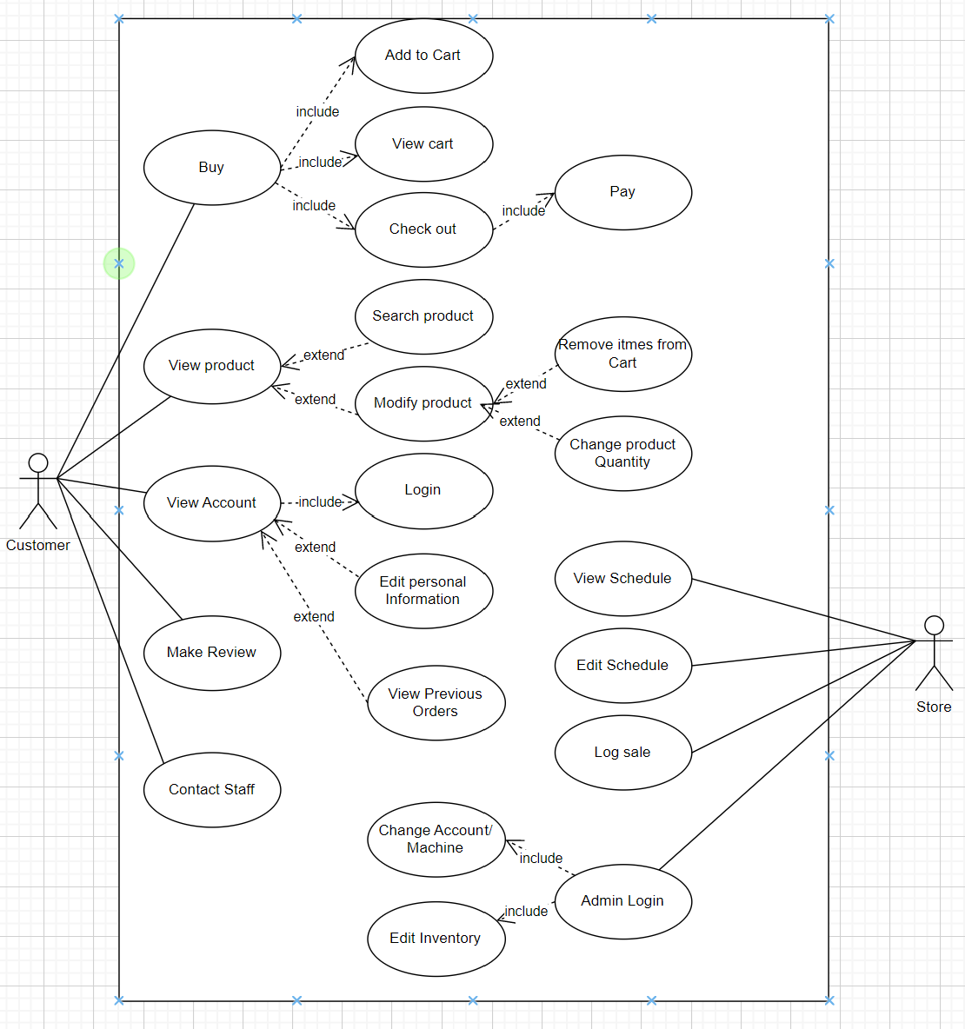

**5.6. TRACEABILITY MATRIX**

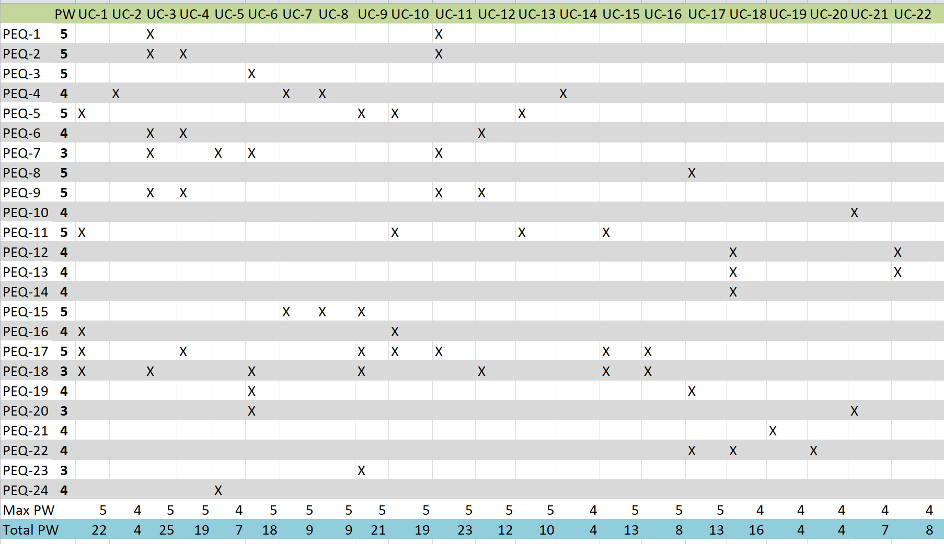

**5.7. USE CASE FULLY-DRESSED DESCRIPTION**

**5.7.1. Login**

This table shows a detailed summary of the Login use case. The interactions are defined as follows:

|  |  |
| --- | --- |
| UC-3: Login | |
| Related Requirements | REQ-1, REQ-2, REQ-6, REQ-7, REQ-9, REQ-18 |
| Primary Actors | Customer |
| Actor’s Goals | Access Personal Account from Database. |
| Secondary Actors | Database |
| Preconditions | The customer wants to access a personal account. |
| Success End Condition | The Customer is now logged into the System. |
| Failed End Condition | Access is denied to login to Account. System state is unchanged. |
| Flow of Events for Main Success Scenario: | |
| 1. → **Customer** clicks on login. 2. ← **System** requests that the customer enter his/her name and password. 3. → **Customer** enters his/her name and password. 4. ← **Database** validates the entered name and password and logs the actor into the system. | |
| Flow of Events for Extensions: | |
| 1. Invalid Name / Password   1. ← **System** displays an error message. 2. → **Customers** can choose to retry the login, register an account, or return to the home page. | |

**5.7.2. Search Product**

This table shows a detailed summary of the Search Product use case. The interactions are defined as follows:

|  |  |
| --- | --- |
| UC-7: Search Product | |
| Related Requirements | REQ-4, REQ-5, REQ-38 |
| Primary Actors | Customer |
| Actor’s Goals | Search and find the items needed. |
| Secondary Actors | Database |
| Preconditions | The customer has an item to search for. |
| Success End Condition | Item was found in Database and is Displayed. |
| Failed End Condition | Item was not find in Database and isn’t displayed. |
| Flow of Events for Main Success Scenario: | |
| 1. → **Customer** clicks on a search item.  2. ← **System** requests that the customer enters itemed needed.  3. ← **Database** validates the entered item is in stock.  4. ← **System** displays items on the screen needed by the customer. | |
| Flow of Events for Extensions: | |
| 1. Invalid Name / Password   1. ← **System** displays an error message. 2. → **Customers** can choose to retry the login, register an account, or return to the home page. | |

**5.7.3. Edit Inventory**

This table shows a detailed summary of the Edit Inventory use case. The interactions are defined as follows:

|  |  |
| --- | --- |
| UC-17: Edit Inventory | |
| Related Requirements | REQ-8, REQ-19, REQ-22 |
| Primary Actors | Manager |
| Actor’s Goals | Add, Remove, Modified item inventory in the Database. |
| Secondary Actors | Database |
| Preconditions | The manager has to edit the inventory. |
| Success End Condition | Items are added, removed, or modified in the Database. |
| Failed End Condition | The changes in the inventory are not reflected in the database. |
| Flow of Events for Main Success Scenario: | |
| 1. → **Manager** clicks on edit inventory.  2. ← **Database** responded with current inventory.  3. ← **System** displays the inventory.  4. → **Manager** adds, removes, or modifies items.  5. ← **Database** updates inventory accordingly to managers input.  6. ← **System** displays the updated inventory. | |

**6. USER INTERFACE PRELIMINARY DESIGN**

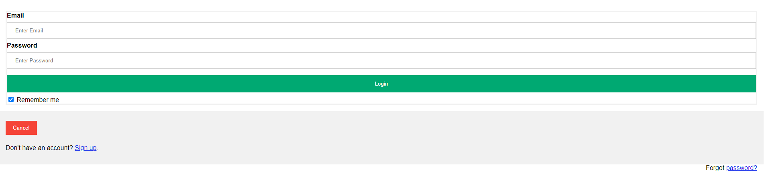

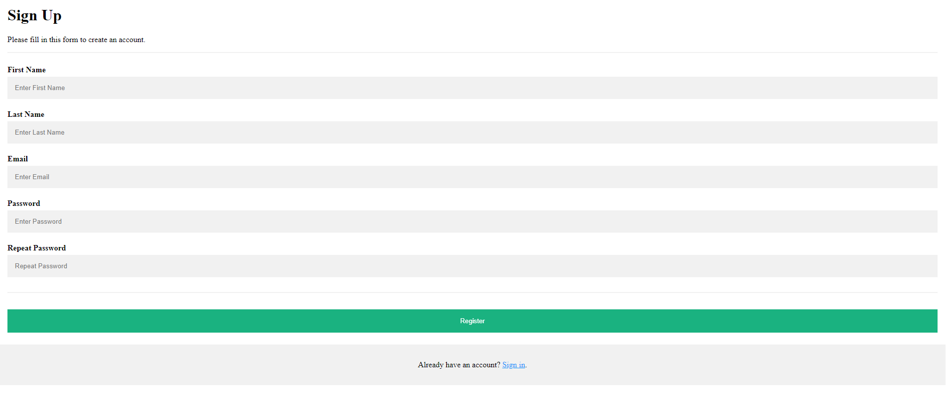

The user interface we have implemented is designed to provide a seamless login experience and maintain a modern yet simple look. The first page of the interface is a login page that requires users to input their registered email address and password. The login page includes options for users to remember their login details, recover their password, and sign up if they are new users. If a user chooses to sign up, they are directed to a page that requires them to provide their first and last name, email and password (twice to ensure security).

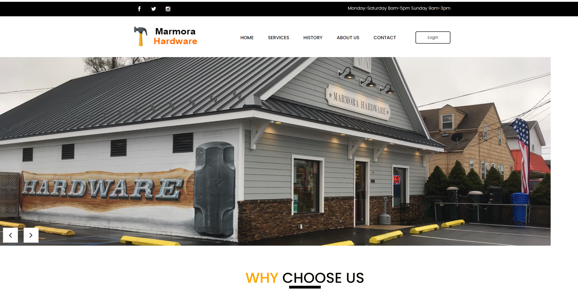

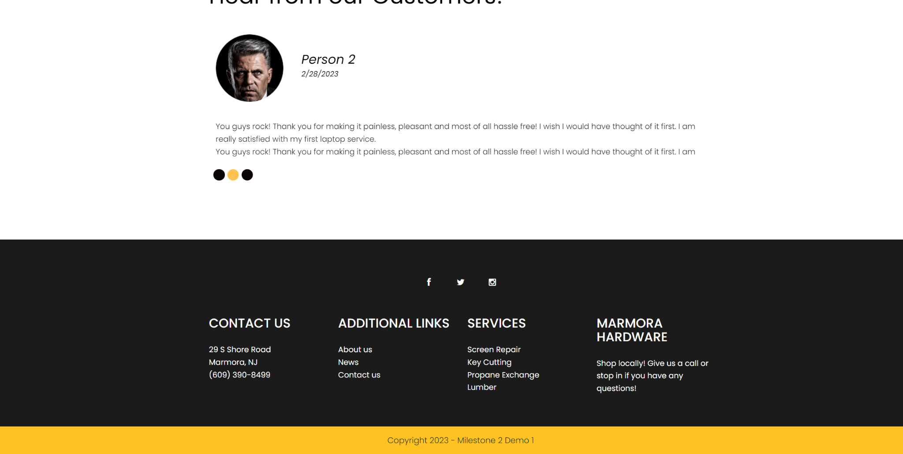

The homepage of the site is a welcome place for customers and employees to view. This page will show the entire store's information like location and hours. From here is where users will be able to login into their account.

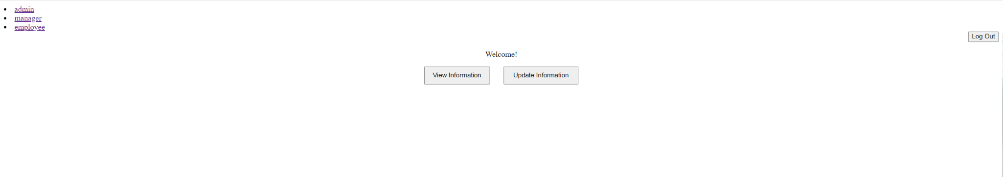

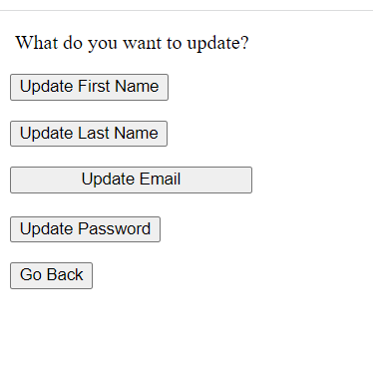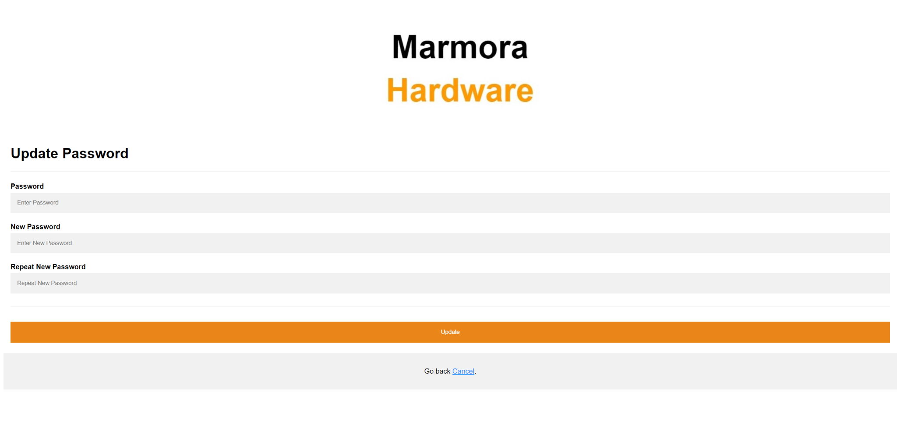

Upon logging in Users are able to view and change their account information. Users are able to update all information like name, email, and password. Like for registering, when updating emails have to not already be used for another account. If the account is an admin, manager, or employee account, there will be a separate tab for these users to be able to do the features associated with their account.

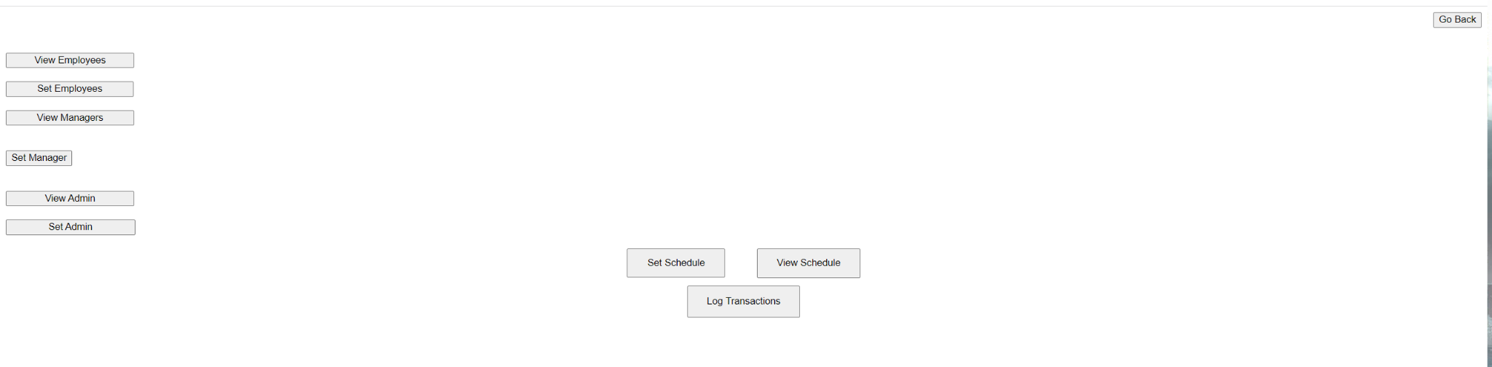

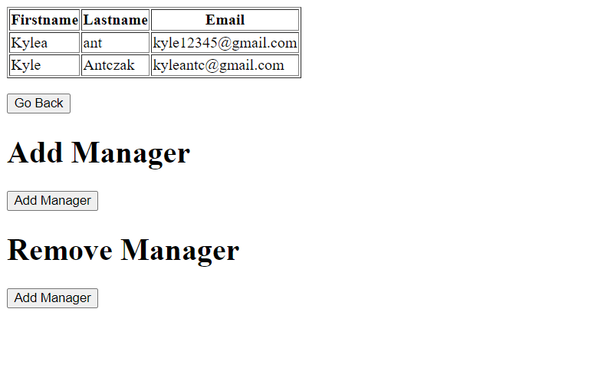

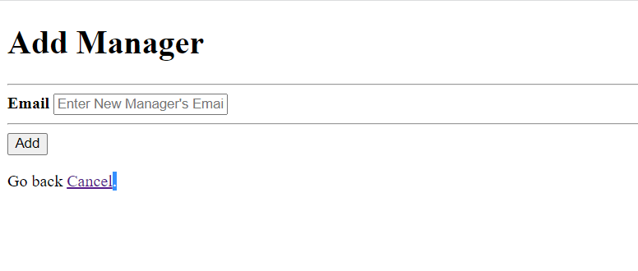

These pictures show off the view of an admin account. Admins are able to change the permissions of other accounts from a customer account to a manager or employee account. When doing this it will show a list of all current managers/employees. Then to add or remove an account the admin just needs to enter the accounts email.

Other features on here include the admin the ability to set/view the employee schedule and log sales. Managers will also have these same abilities. An employee account will only be able to view the schedule.

**7. SYSTEM ARCHITECTURE AND SYSTEM DESIGN**

**7.1. ARCHITECTURAL STYLES** (explain which architecture style of your SW, details are expected such as which programming languages to be used)

**7.2. DATABASE DESIGN (If applicable)**

**7.2.1. E-R Diagram**



**7.2.2. Tables**

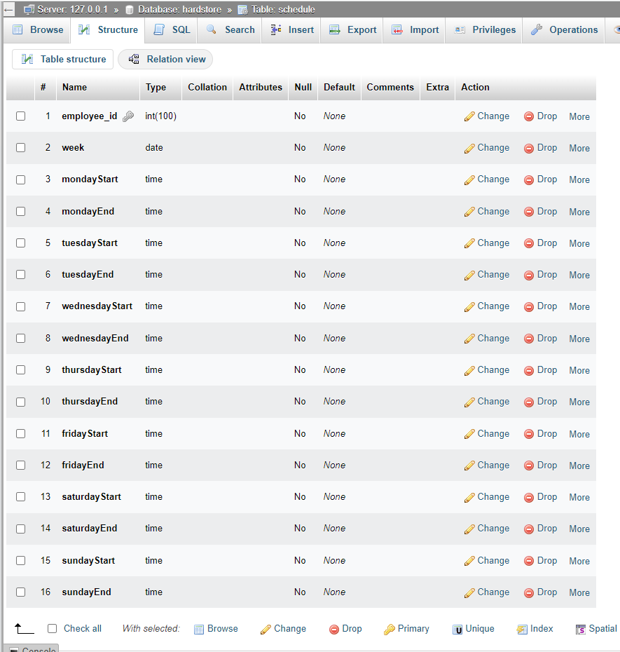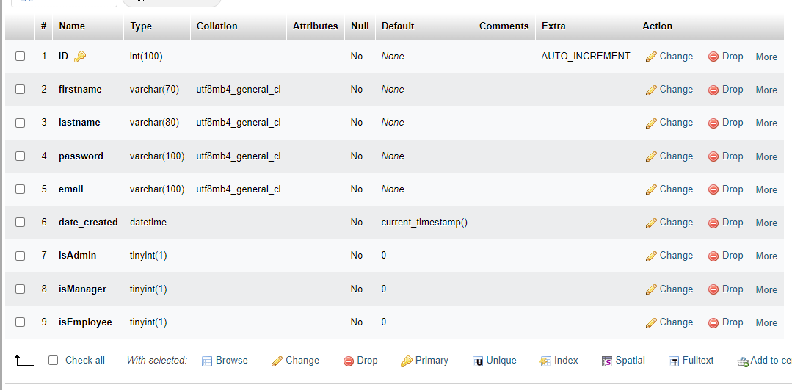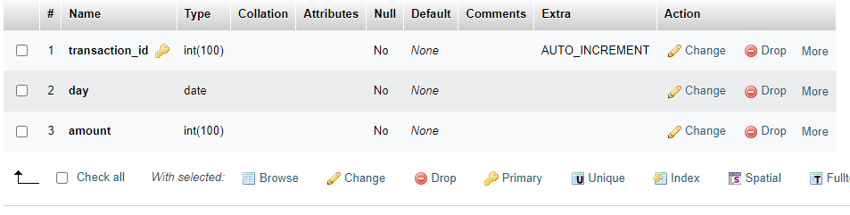

**8. IMPLEMENTATION**

**8.1. REQUIREMENTS IMPLEMENTED IN MILESTONE#3**

|  |  |
| --- | --- |
| REQ ID | Implemented in milestone#3 (Yes/No) |
| 01 | Yes |
| 02 | Yes |
| 03 | Yes |
| 04 | No |
| 05 | Yes |
| 06 | Yes |
| 07 | No |
| 08 | Yes |
| 09 | Yes |
| 10 | Yes |
| 11 | Yes |
| 12 | Yes |
| 13 | Yes |
| 14 | Yes |
| 15 | No |
| 16 | No |
| 17 | No |
| 18 | No |
| 19 | Yes |
| 20 | Yes |
| 21 | Yes |
| 22 | Yes |
| 23 | No |
| 24 | No |

**9.2. GITHUB LINK** (please provide URL of source code below)

<https://github.com/AKAKyleA/milestone3/tree/main/Marmora%20Hardware>